Practical 7
Code : https://github.com/bhavyakumar18/DSA/tree/main/Practical%207
Problem 1
I faced difficulty in managing the front and rear positions of the fixed-size queue, especially when elements were removed and new elements were added. I solved this by using a circular queue, where front points to the first token and rear points to the last token. Before joining, I checked whether the queue was full, and before serving, I checked whether it was empty. The circular approach also helped me reuse the spaces that became free after serving tokens.
Output:
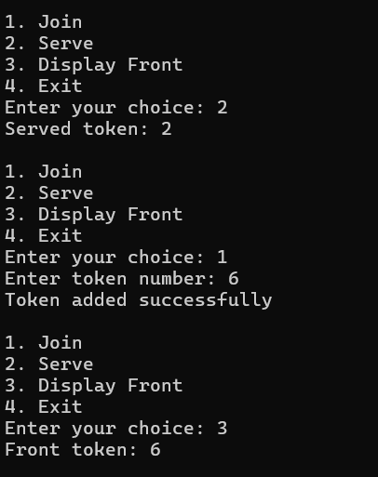

Problem 2
I faced difficulty in managing the queue because there was no fixed size. I solved this by using a dynamic linked queue, where new patients are added at the rear and patients are removed from the front. I maintained separate front and rear pointers and updated them after every arrive and attend operation. If there are no patients left, I display that the queue is empty.
Output:
